Homework for Chapter 21: Partial Identification

1. Which of the following shows the distinction between weak and strong assumptions?
   1. Weak assumptions assume less than strong assumptions.
   2. Weak assumptions are suited to imprecisely measured data, while strong assumptions assume data is precisely measured.
   3. Strong assumptions are when you make any sort of assumption about the unobserved part of your data, while weak assumptions mean no assumptions.
   4. We call assumptions strong if we think they’re true, and weak if we are not confident that they’re true.
2. You are interested in calculating the share of students in country X that can pass a fitness test. Unfortunately, in country X, they only give the test to boys, and not to girls, so you have no data on girls. You know that 50% of students are boys, and that 80% of those boys pass the test.
   1. Knowing that the share of girls that pass the test must be between 0% and 100%, construct a set of partial identification bounds on the share of all students that pass the test.
   2. Propose another assumption about girls that will allow you to narrow the partial identification bounds. Recalculate your bounds.
3. Consider the following sensitivity graph made using the Cinelli & Hazlett (2020) method:  
   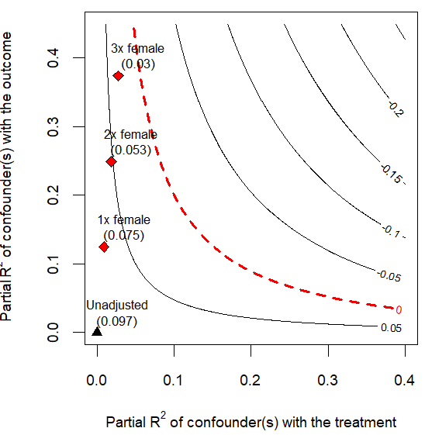  
   This comes from the package’s example data, which looks at the impact of refugees being directly harmed during the attacks on villages in Darfur in 2003-2004 on their attitudes towards peace. They find that being directly harmed increases pro-peace attitudes by .097 on a 0-1 scale, while controlling for gender, age, household size, past voting status, occupation, and the respondent’s village. Interpret the meaning of the “2x female (0.053)” point on the graph. What does it mean literally, and what does it say about the robustness of the results?
4. You are performing a sensitivity test of your analysis using the Cinelli & Hazlett (2020) method. Your analysis is of a home loan protection program. Low-income homebuyers are eligible, and may voluntarily sign up at no cost to them. If they do, then the program offers to cover a month of mortgage payments in the case that the homeowner loses their job. You are interested in the effect of being enrolled in the program on whether a home is foreclosed upon. You regress foreclosure on being enrolled in the program, controlling for the homeowner’s race, gender, age, and income at the time of buying the home. You find that being enrolled in the program reduces foreclosure rates by 5 percentage points. You also find that your result is robust to an omitted variable that is 80% as strong as “income at the time of buying the home”, but no stronger. You assume that there is no such omitted variable. Assess whether you think this assumption is reasonable, and why. There’s not a single right answer, but explain your thought process.
5. You perform a Rosenbaum Bounds estimate, and find that your effect loses significance at a $Γ$ value of 1.8.
   1. Based on this $Γ=1.8$ value, write the set of bounds for $π_{t}/(π_{t}+π_{u})$.
   2. Write a sentence interpreting your bounds from part a.
6. In 2022, a new fintech app Rizzl launched, offering high-interest loans on demand by app in four countries. You use difference-in-differences to analyze the effect of the app launch on personal debt levels in 2024.
   1. (You may need to go back to the difference-in-differences chapter for this!) State, in a sentence, what the parallel trends assumption means in this context.
   2. Your estimate is that the app launch increased personal debt levels by $200 per person. If parallel trends is violated, such that even if the app hadn’t launched, the control countries would have seen personal debt levels decline by $50 more in 2024 than treated countries, what is the true effect of the app?
   3. If you are willing to assume that the parallel trends violation is somewhere between $-\$100$ and $\$100$, what is the partial identification bounds for your estimate (your “honest DID” bounds)?